|  |
| --- |
| PRIVATE-EYE  IRFAN ALI SHAH  YASIR MASOOD |
| LOGO CIIT |
|  |
| **APRIL 2021** |
|  |
| Department of Computer Science  COMSATS UNIVERSITY ISLAMABAD  ATTOCK – PAKISTAN |

|  |  |  |  |  |  |  |
| --- | --- | --- | --- | --- | --- | --- |
| **PROJECT ID** | |  | |  | **NUMBER OF MEMBERS** | 2 |
|  | | | | | | |
| **TITLE** | Private-Eye | | | | | |
|  | | | | | | |
| **SUPERVISOR NAME** | | | Miss Sadia Ijaz | | | |

|  |  |  |
| --- | --- | --- |
| **MEMBER NAME** | **REG. NO.** | **EMAIL ADDRESS** |
| Irfan Ali Shah | CIIT/SP18-BCS-006/ATK | [irfanshah5457@gmail.com](mailto:irfanshah5457@gmail.com) |
| Yasir Masood | CIIT/SP18-BCS-046/ATK | [ym7500131@gmail.com](mailto:ym7500131@gmail.com) |

**CHECKLIST:**

|  |  |  |  |
| --- | --- | --- | --- |
| Number of pages in this report |  |  |  |
| I/We have enclosed the soft-copy of this document along-with the codes and scripts created by myself/ourselves | **YES / NO** | | |
| My/Our supervisor has attested the attached document | **YES / NO** | | |
| **I/We confirm to state that this project is free from any type of plagiarism and misuse of copyrighted material** | **YES / NO** | | |
|  |  | | |

|  |  |  |
| --- | --- | --- |
| **MEMBERS’ SIGNATURES** |  | |
|  |  | Supervisor’s Signature |
|  |  |
|  |  |

**This work, entitled “Private-Eye” has been approved for the award of**

**Bachelors of Science in Computer Science**

**Date: 10/April/2021**

**External Examiner:**

**Head of Department:**

Department of Computer Science

COMSATS UNIVERSITY ISLAMABAD

ATTOCK – PAKISTAN

****Declaration****

*“No portion of the work referred to in the dissertation has been submitted in support of an application for another degree or qualification of this or any other university/institute or other institution of learning”.*

|  |
| --- |
| **MEMBERS’ SIGNATURES** |
|  |
|  |
|  |

Acknowledgements

Start’s with the Name of ALLAH, the kindest and the most merciful.

Thanks for ALLAH almighty who make us able to start working our project. We would like to thank our parents who kept us backing up in all the times, both financially and morally.

We would like to thank our family members and teachers who were not directly involved in the project but, in fact, without them we were never able to complete this job.

We would like to thank all those people who supported us in getting learning data and helped us in testing our models.

I am grateful to the God Almighty who gives all the resources of every kind to us, so that we make their proper use for the benefit of mankind. ALLAH keeps providing us with all the resources, and the right direction to help the humanity.

Abstract

The human life has become very technical; they have a more things in mobile phones. They need some special arrangements to keep their mobile phones secure. Private-Eye is a mobile application, developed for android operating system. Private eye is an android app which will trace smart phone if the owner of that phone lost his/her phone in the absence of user in such a way that someone caught his/her mobile. The owner can easily get location details of his/her mobile and will also get the picture of that person who is trying to unlock the phone .The owner will get location and picture on email if has installed this app in his/her android phone . It basically helps the owner to find his/her phone*.*

Table of contents

1 Introduction 1

1.1 Problem statement 2

1.2 Proposed Solution 2

1.3 Explanation 2

1.4 Scope 3

2 Literature Review 4

2.1 Private-eye 4

2.2 features and architecture 4

2.3 Related work 4

3 Requirement Specification 6

3.1 Introduction 6

3.1.1 Purpose 6

3.1.2 Product scope 6

3.2 Overall Description 7

3.2.1 Product Functions 7

3.3 Operating Environment 7

3.3.1 Design and Implementation Constraints 7

3.4 System Features 7

3.5 Non-functional Requirements 7

4 Project Design 8

4.1 Design Description 8

4.2 Data flow diagram...................................................................................................8

4.2 Activity Diagram 9

4.3 Use Case diagram 10

**Chapter 1**

**Introduction**

# Introduction

The Private eye is basically an android application which is useful for smart phones and it will work only in smart phones .This app will actually help to find the phone if the owner will lost his/her phone

The user can activate this application by using the other phone by sending a specific message.

In this app the owner will set the lock for his/her phone screen and will provide an email address on this app. Now if he/she lost his/her phone then definitely another person will get his/her phone and will try to unlock the phone. Definitely he will try wrong password because he do not know the right one. The owner will select the no of attempts for wrong password so if the thief tries some wrong attempts then this app will be active and will send the location on email and will also take the picture of his face of that person and will send it with location. The owner will also get the live location on Gmail. If he is trying wrong password again and again then this app will not send the same location and same face picture again. It will send the location and face picture again when the phone is moved 1km away from the previous location. If the phone is moving from one place to another then the owner can follow him and can find his/her phone.

If the owner forgot the phone somewhere then owner can turn on the data network and location using specific message and can find the phone by getting location on Gmail.

If your phone has been stolen then you will activate the Private eye app by sending the specific message from other phone. One time if this is activated the thief can’t turn off the Location and data network. If the phone is not in the network area then the Private eye will send the last network area location. If the thief is too much smart and he has been unlocked the phone then you will get the notification on Gmail.

The owner of phone do not need to worry and no need to go to different shops for finding the lost phone. He/she will easily find the phone with the thief.

## Problem statement

As we all know the how expensive are the smart phones now and also phone contains the much personal data of its owner. There is not any quick way to find the phone if the owner lost it.

## Proposed Solution

The private eye app will help to find the phone as quick as possible. The owner of phone doesn’t need to go to anyone for help .He/she alone can easily find the phone.

So basically it is quick and more efficient.

## Explanation

The application has focused on following type of works

* Alert Message

When a picture is taken, tell the crook to return your phone, or else...

* Retry Email

If disconnected from the internet, postpone emails until back online

* Hide Notification

Don't let the thief know that you got him on camera

* Detection

Take a photo when the crook guesses the right password after having failed.

**Features:**

* Takes photo with secret camera when someone tries to unlock your phone with the wrong code.
* Sends location and photo to the given email.
* It will work with password, pin and pattern lock.
* You can select number of attempts before picture is taken.
* It will be completely silent and secret.

## Scope

Private-Eye is an intelligent application which will handle the mobile in absence of user. As we all know the how expensive are the smart phones now and also phone contains the much personal data of its owner. There is not any quick way to find the phone if the owner lost it. The private eye app will help to find the phone as quick as possible. The owner of phone doesn’t need to go to anyone for help .He/she alone can easily find the phone. So basically it is quick and more efficient.

**Chapter 2**

**Literature Review**

# Literature Review

With the passage of time, the life of human gets easier with new advancements every day. People do not need to take more worries about their work because most of their works in now performing with the machines. Smart devices have also created a sound sight of easiness and luxury. If you look back on 10 years ago, the situation of that time was quite different to the present days. People have much more to do with their self, regard less of the effort that they utilize on them. But, with the passage of time, the things are now going to perform task by their selves without the supervision of humans. The world is now, day by day, moving forward to the Artificial intelligence and Machine learning to occupy the burden of work from their shoulder to different machines like smart devices.

As we all know the how expensive are the smart phones now and also phone contains the much personal data of its owner. There is not any quick way to find the phone if the owner lost it.

People are, nowadays, want an application that can find their phone after losing and perform task better than people their selves. Advancements are taken place to get people life not only easy but also automated so that people have not only the less burden but also their duties and task are performed in well manners.

The private eye app will help to find the phone as quick as possible. The owner of phone doesn’t need to go to anyone for help .He/she alone can easily find the phone. So basically it is quick and more efficient.

## Private-Eye

Private-Eye is a mobile application, developed for android operating system. Private eye is an android app which will trace smart phone if the owner of that phone lost his/her phone in the absence of user in such a way that someone caught his/her mobile. The owner can easily get location details of his/her mobile and will also get the picture of that person who is trying to unlock the phone .The owner will get location and picture on email if has installed this app in his/her android phone . It basically helps the owner to find his/her phone*.*

**Features and Architecture:**

* Takes photo with secret camera when someone tries to unlock your phone with the wrong code.
* Sends location and photo to the given email.
* It will work with password, pin and pattern lock.
* No battery drain.
* You can select number of attempts before picture is taken.
* It will be completely silent and secret.
* You can connect two private eye apps and can activate each other’s.
* You can perform some settings.

**Related Work**

**IMEI Tracking:**

* In IMEI tracking system if you lost your phone. You will go to police station and police will ask IMEI number to track your phone and if you do not know the IMEI code then you will have to go to mobile office to get IMEI number.

**Find my I phone:**

* It is an application which is used to find the location of I phone smart phone. This is not for Android Smart phones.

**Private eye:**

* Our app mission is to find the android smart phone as quick as possible and without any other person help and to find till the death of phone.

**Chapter 3**

**Requirements Specification**

# Requirement Specification

## 3.1 Introduction

### Purpose

Private-Eye is an intelligent android application to assist human while using android phone. The Software Requirement Specification is written to collect and mention the requirements which are essential in creation of project. These requirements are covering the entire system and need for developing this application.

### Product scope

Private-Eye is for users which can be students, business men, employees or household persons. The private eye app will help to find the phone as quick as possible. The owner of phone doesn’t need to go to anyone for help. All the 12+ users can use the application.

## Overall Description

### Product Functions

* User can lost the phone; there should be an application who can find the mobile in absence of user.
* Application should take care of android phones. It should perform actions according to user needs.
* It should keep secure user phone.
* The forgetting the phone can be the time of Sleep, Prayer, work and one more other than early mentioned, can be pronounce as Default.
* Work, Sleep and Prayer may have different preferences depends upon user. These activities can be present at any time of the day, at any place, at any style. The application should have facilitation to keep secure the phone from thief.

## Operating Environment

The application should be developed in android studio and can be run on any android supported platform. It should be compatible with all android operating systems with 4.2 and later.

### Design and Implementation Constraints

Private-Eye can only be developed on all mobile devices platforms for personal assistance. Private-Eye is a mobile application, developed for android operating system. Private eye is an android app which will trace smart phone if the owner of that phone lost his/her phone in the absence of user in such a way that someone caught his/her mobile.

## System Features

Features are defined in previous chapter.

## Non-functional Requirements

The application should have following NFRs.

* The application should be run on android operating system.
* The application should save records at least one year.
* Minimum API for android operating system should be 17
* Application should run in background, so that battery can be saved.
* Application should be multitasking; it’s all components must work in parallel.
* Application should not use internet continuously.
* No rush of notifications would be created by the application.

**Chapter 4**

**Project Design**

# Project Design

## Planning phase

In first phase of this development, the requirements of the projects were gathered. (The requirements are present in chapter 3).

## Risk Analysis

Right after the requirement gathering, risk analysis was the most important of this project. Since the project has highly involved concerns related to user privacy, so at each step, the risk was taken under account and tried to maintain the privacy of user’s routine and location.

## Data Flow Diagram

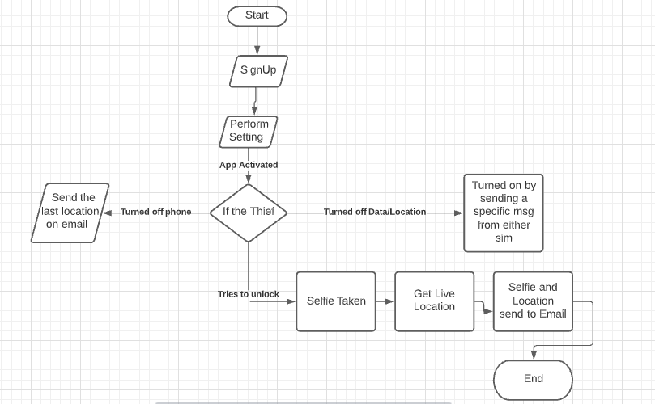

## Use Case Diagram

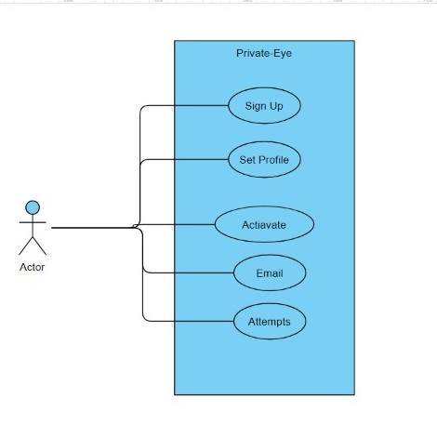

Sequence Diagram:

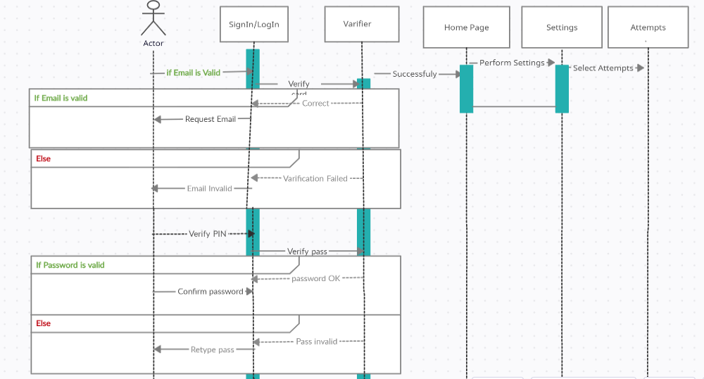

## Activity diagram

Activity diagram for message analysis is shown in below figure.

